BHAVISHKA KUMARI 26K 3130
TASK1
#include <stdio.h>

int main() {
Int prev_reading, curr_reading, units_consumed;
double bill_amount = 0.0;

printf("Enter previous meter reading: ");
if (scanf("%d", &prev_reading) != 1) return 1;

printf("Enter current meter reading: ");
if (scanf("%d", &curr_reading) != 1) return 1;

if (curr_reading < prev_reading) {
curr_reading += 10000;
}

units_consumed = curr_reading - prev_reading;

if (units_consumed < 0) {
printf("Invalid Reading\n");
return 0;
}

if (units_consumed <= 100) {
bill_amount = 0.0;
}
else if (units_consumed <= 200) {
bill_amount = (units_consumed - 100) * 2.00;
}
else if (units_consumed <= 400) {
bill_amount = (100 * 2.00) + (units_consumed - 200) * 3.50;
}
else {
bill_amount = (100 * 2.00) + (200 * 3.50) + (units_consumed - 400) * 5.00;
}

if (units_consumed > 500) {
bill_amount = bill_amount * 1.15;
}

printf("\nUnits Consumed: %d\n", units_consumed);
printf("Final Bill Amount: Rs. %.2f\n", bill_amount);

return 0;
}
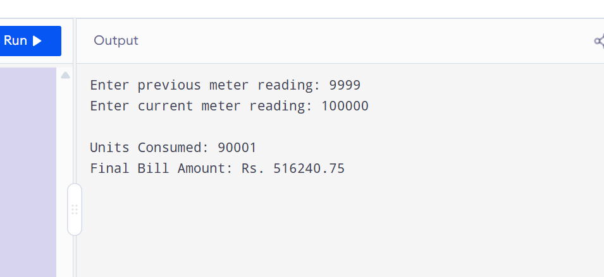

TASK2
#include <stdio.h>

int main() {
int age, has_fever;
float weight;

printf("Enter age (years): ");
if (scanf("%d", &age) != 1) return 1;

printf("Enter weight (kg): ");
if (scanf("%f", &weight) != 1) return 1;

printf("Has fever? (1 for yes, 0 for no): ");
if (scanf("%d", &has_fever) != 1) return 1;

printf("\n--- Result ---\n");

if (age < 2) {
printf("Consult Doctor\n");
}
else if (age >= 2 && age <= 12) {

if (weight < 20.0) {

if (has_fever == 1 && weight < 15.0) {
printf("Consult Doctor\n");
} else {
printf("2.5 ml\n");
}
}

else {
printf("5 ml\n");
}
}
else if (age > 12) {
if (has_fever == 1 || weight > 70.0) {
printf("10 ml\n");
}
else {
printf("7.5 ml\n");
}
}

return 0;
}
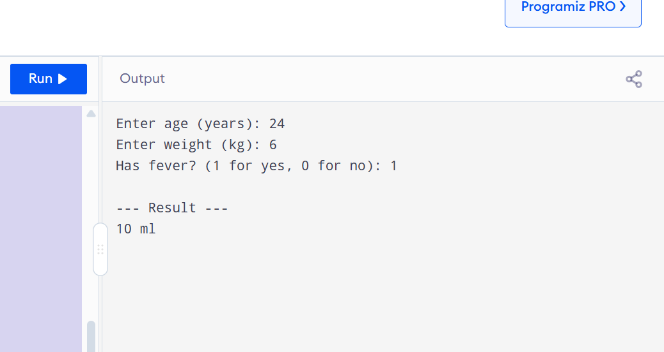

TASK3

#include <stdio.h>

int main() {
int status;
int t, a, f, l;
printf("Enter current status (0-15): ");
scanf("%d", &status);

status = status ^ 2;
l = status & 1;
f = (status >> 1) & 1;
a = (status >> 2) & 1;
t = (status >> 3) & 1;
printf("Step A output: Light=%d, Fan=%d, AC=%d, TV=%d\n", l, f, a, t);

status = status | 4;
l = status & 1;
f = (status >> 1) & 1;
a = (status >> 2) & 1;
t = (status >> 3) & 1;
printf("Step B output: Light=%d, Fan=%d, AC=%d, TV=%d\n", l, f, a, t);

status = status & ~1;
l = status & 1;
f = (status >> 1) & 1;
a = (status >> 2) & 1;
t = (status >> 3) & 1;
printf("Step C output: Light=%d, Fan=%d, AC=%d, TV=%d\n", l, f, a, t);

if ((status & 8) != 0) {
status = (status << 1) & 15;
}

l = status & 1;
f = (status >> 1) & 1;
a = (status >> 2) & 1;
t = (status >> 3) & 1;
printf("Step D output: Light=%d, Fan=%d, AC=%d, TV=%d\n", l, f, a, t);

printf("\n--- Final Status ---\n");
printf("Light: %d\n", l);
printf("Fan: %d\n", f);
printf("AC: %d\n", a);
printf("TV: %d\n", t);

return 0;
}
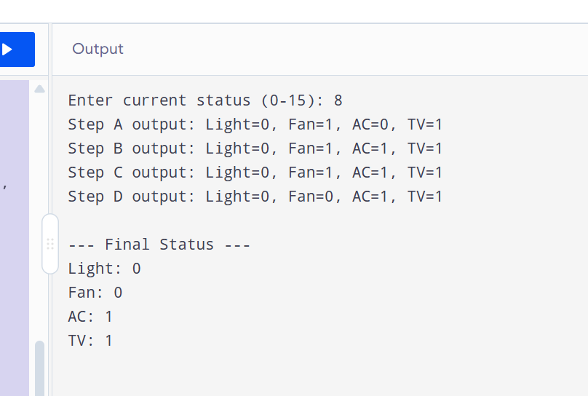

TASK4
#include <stdio.h>

int main() {
float attendance;
int marks, unapproved_absences;
printf("Enter attendance percentage: ");
scanf("%f", &attendance);

printf("Enter internal marks (out of 50): ");
scanf("%d", &marks);

printf("Enter unapproved absences: ");
scanf("%d", &unapproved_absences);

printf("\nStatus: ");

if (marks < 20) {
printf("Debarred\n");
}

else if (attendance >= 75.0 && marks >= 30) {
printf("Eligible\n");
}

else if (attendance >= 65.0 && attendance <= 74.0 && marks >= 40) {

if (unapproved_absences > 2) {
printf("Debarred\n");
} else {
printf("Eligible (Grace Attendance)\n");
}
}
else {
printf("Not Eligible\n");
}

return 0;
}


